Assignment
20220762
Gold Okereke

Prepared Queries

Parents of Jess
father_of(X, jess).
mother_of(X, jess).

Sibling of Jess
sister_of(X, jess).
brother_of(X, jess).

Parents of James
father_of(X, james).
mother_of(X, james).

Parents of Simon
father_of(X, simon).
mother_of(X, simon).

Parents of Harry
father_of(X, harry).
mother_of(X, harry).

Grandparents of Simon
grandfather_of(X, simon).
grandmother_of(X, simon).

Grandparents of Harry
grandfather_of(X, harry).
grandmother_of(X, harry).

2)

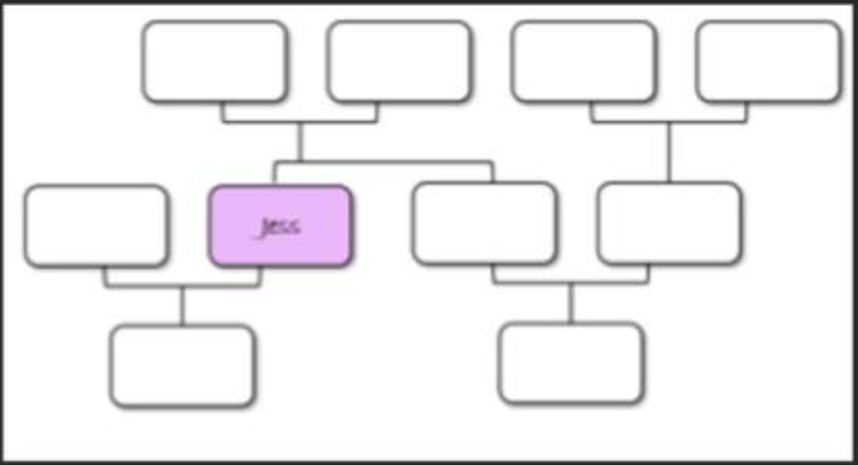
Harry
Jack
Simon
Lily
James
Ali
Sophie
Oliver
Helen
3)

